**Singapore 6 Nights / 7 Days**

**Day 1 – Arrival at Singapore airport**

Meet & assist at airport. Transfer to hotel. Free time at your own for rest.

**Day 2 – Singapore Flyer:**

07:00 – 09:00 Buffet breakfast in restaurant.

10:00 Pick up for Singapore Flyer. Singapore Flyer is the world’s largest Giant Observation Wheel and is set to be one of Asia’s biggest tourist attractions. Featuring fixed capsules the size of a bus, the spectacular monument is capable of holding up to 784 passengers. Each capsule has a 28 person capacity and each revolution takes approximately 30 minutes. Singapore Flyer was conceived and designed by Dr. Kisho Kurokawa and DP Architects, Singapore. It held its groundbreaking ceremony in September 2005 and was launched in 2008.

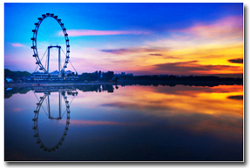

It promises more than just a view, but a panorama that captures Marina Bay’s skyline with a glimpse of neighboring Malaysia and Indonesia.   
  
With high standards of service, the dedicated team at Singapore Flyer (Pvt.) Ltd. is committed to providing visitors an experience to remember. Singapore Flyer offers a breathtaking panorama of the shimmering Marina Bay waterfront and historical landmarks dotting the city skyline. Includes facilities, sights and sounds to explore, dining and shopping – everything you need to know to make your trip to the Flyer a successful and memorable one.

**Day 3 – City Tour:**

07:00 – 09:00 American Breakfast in restaurant.

09:00 Pick up for City Tour and visit to Parliament House, the oldest building in the country. The Historical Chinatown, a delightful fusion between the hustling shops, restaurants, popular streets and national heritage sites. Sri Mari Amman Temple, the oldest Hindu temple in Singapore where the ‘Fire Walking’ festival is celebrated. Botanical Gardens, with over 52 hectares (128 acres) of landscaped parkland and primary jungle and are situated to the west of the city, home to a wide range of animal and plant life. The central business district is the financial pulse of the city surrounded by gleaming towers of commerce. Little India, a wonderful orchard road – the ‘Fifth Avenue’ or ‘Oxford Street’ of Singapore, dominated by high class hotels this is the playground of Singapore’s elite, this place is bustling with shopping centers, nightspots, restaurants, bars and lounges. Singapore Gems Factory, where you can admire the best of Asian craftsmanship, watch artisans working on gemstones and carve out beautiful shapes. Transfer to hotel.

**Day 4 – Universal Studio:**

07:00 – 09:00 Buffet Breakfast in restaurant.

10:00 Pick up for Universal Studio. Universal Studios Singapore is a theme park located within Resorts World Sentosa on Sentosa Island, Singapore. It was a key component of Genting's bid for the right to build Singapore's second integrated resort. On December 8, 2006, the Singapore government announced that the consortium had won the bid, and the construction of the theme park and the rest of the resort started on April 19, 2007. It is the second Universal Studios Theme Parks to open in Asia, and the first in Southeast Asia. The official plans for the park were unveiled to the public when Universal Studios Singapore released a map of it to the public on October 20, 2009.

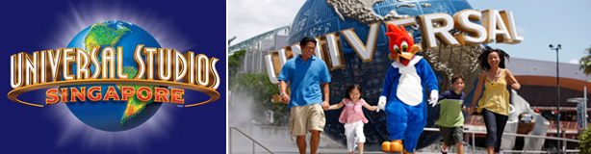

**Hollywood**   
  
Pantages Hollywood Theatre is a Broadway-style theater to host plays, musicals and performances. The show is set in a 1,500-seat indoor theater, featuring the famous Universal Monsters in the rock-n-roll musical "Monster Rock!"   
  
**New York**  
  
Lights! Camera! Action! Hosted by Steven Spielberg is a show where guests can be blown away by the filmmaker's incredible special effects as an empty sound stage becomes the setting for a major hurricane about to hit New York City. Stage 28 unravels the secrets of film production. This attraction is set in a fully-outfitted state-of-the-art sound stage for motion picture and television production. Guests can see some of Universal feature films and props and get behind the scenes and see real film production right before their very own eyes.

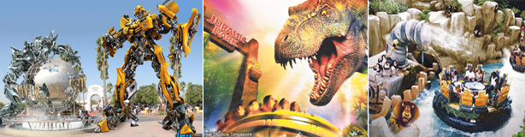

**Sci-Fi City**  
  
The Sci-Fi City is a real-life imagination of how a common metropolis of the future would look like containing the many modern conveniences of life as well as the remnants of past inhabitants and cultures which were once part of the city as well as international visitors from all over the world and other planets. The city is based on the popular television series, Battlestar Galactica, and features the world's tallest Dueling roller coaster.   
  
**The Lost World**  
  
This zone contains many traditional attractions present in most Universal Studios parks around the world and is divided into two sub areas: Jurassic Park and WaterWorld. Jurassic Park, based on the popular film franchise by Steven Spielberg and novels by Michael Crichton, features the newly redesigned Jurassic Park Rapids Adventure which is based on the popular Jurassic Park River Adventure attraction in other Universal Studios parks. Waterworld contains mainly water-based attractions and is based on the film Waterworld starring Kevin Costner.

**Day 5 – Shopping & Singapore Night Safari**

07:00 – 09:00 Enjoy Buffet Breakfast in restaurant.

09:00 – 16:00 free time for shopping at your own.

16:00 Pick up for Singapore night Safari. Night Safari is the world’s first safari park for nocturnal animals. It spans 40 hectares of secondary forest and is home to over 1,040 animals. Night Safari, having won the STB Best Leisure Attraction Experience seven times, receives more than 1.1 million visitors annually.   
  
Luring visitors with its world class service quality, product offerings and physical surroundings, Night Safari now boasts of a new entrance, refurbished facilities and new programmes such as tribal performances.

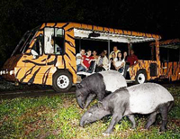

The park’s award-winning Gourmet Safari Express, in which visitors dine onboard a tram traversing Night Safari, features new menus and a refreshed itinerary incorporating the popular Creatures of the Night wildlife show. This dining experience is a Gold Award winner in the prestigious International Festivals and Events World Forum (IFEA) Pinnacles Awards 2001. Popular among visitors, the capacity of the dine-in tram has been expanded to accommodate 72 people.

**Cultural Performances:** 

* Night Safari presents the fire-eating, acrobatic and roaring Thumbuakar! Don’t miss this entertaining display of ethnic dances, scorching stunts and blowpipe demonstrations! Watch as our human torches exhale flames up to 5 metres high!
* Take home a photo memento when you visit Night Safari! For just S$10.00, up to 5 persons can enjoy a close-up experience with a serval, owl or snake. With this contribution, visitors get a professionally-taken photograph, and can also take snapshots using their own camera, if they like.
* Get ready for a 30-minute non-stop action packed show as our star animals, the binturongs, otters, raccoons, wolves, hyenas and many more demonstrate and amaze you with their predatory and survival instincts!

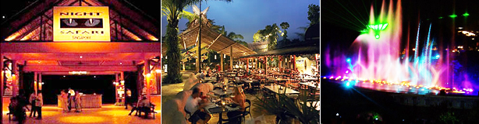

The dark holds many surprises and more so at the Night Safari, where you can look a one – homed rhinoceros in the eye or hear the howls of a pack of striped hyenas. There are 1,200 animals of over 100 exotic to watch out for. Strike out on your own along the walking trail or relax in a tram ride - whichever you choose, the night safari is a wild adventure not to be missed.

Day 6 – Sentosa

07:00 – 09:00 Enjoy Buffet Breakfast in restaurant.

09:00 Pick up for Sentosa tour. Located just 15 minutes from the city, Sentosa, Asia’s Favourite Playground, is home to an exciting array of themed attractions, award-winning spa retreats, lush rainforests, golden sandy beaches, resort accommodations, world-renowned golf courses, a deep-water yachting marina and luxurious residences. Spread over 500 hectares, the vibrant island resort is ideal for both business and leisure. In 2010, Sentosa welcomed Singapore’s first integrated resort, Resorts World™ Sentosa, which operates South East Asia’s first Universal Studios theme park.

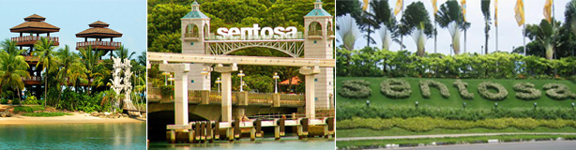

The island resort is managed by Sentosa Development Corporation, which works with various stakeholders in overseeing property investments, attractions development, operation of the various leisure offerings, and management of the residential precinct on the island. The Corporation also manages the Southern Islands, and owns Mount Faber Leisure Group, which runs Singapore’s only cable car service.

Day 7 – Singapore Airport

07:00 – 09:00 Enjoy Buffet Breakfast in restaurant. Transfer to airport.